Book a SCORE Appointment at the Silver Spring Library
Go online to the Scheduling Page > https://score-silver-spring-library.as.me/schedule.php 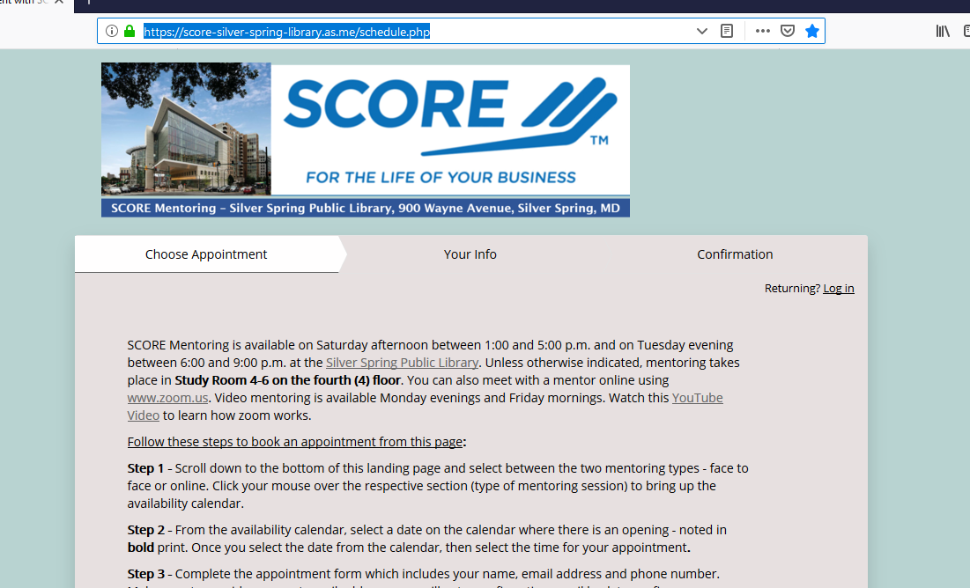
Step 1 – Scroll down to the bottom of the scheduling page and point and click your mouse over one of two sections on the page: SCORE Mentoring Session - Face to Face or SCORE Online Video Session using Zoom
Click your mouse to bring up the Calendar which will show available appointments by date on the calendar
Step 2 – From the Calendar, find a date in bold print – this is the next available opening. In the example below, the next opening is on October 28, 2019. Select the time for the appointment:
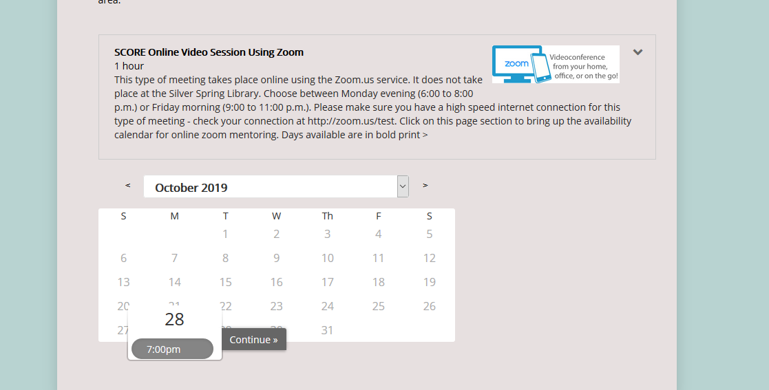
Step 3 – Now that you have selected the session type and date / time, now complete the Confirmation step by completing a simple form that consists of your name, phone number and email address.
NOTE: If you would like to get a text reminder before the appointment, you should enter your cell phone number as the phone number on the confirmation form.
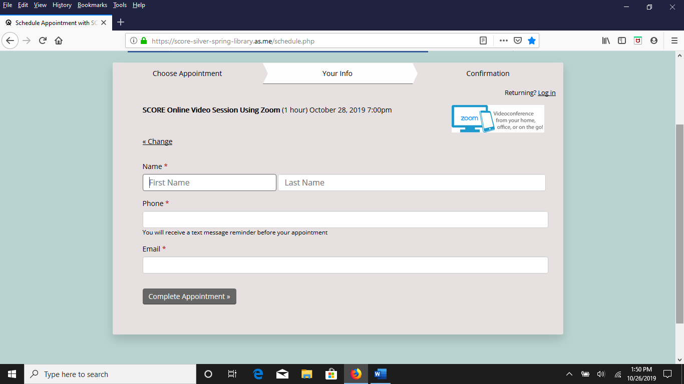
Click the button Complete Appointment. You will get a confirmation back online as follows:
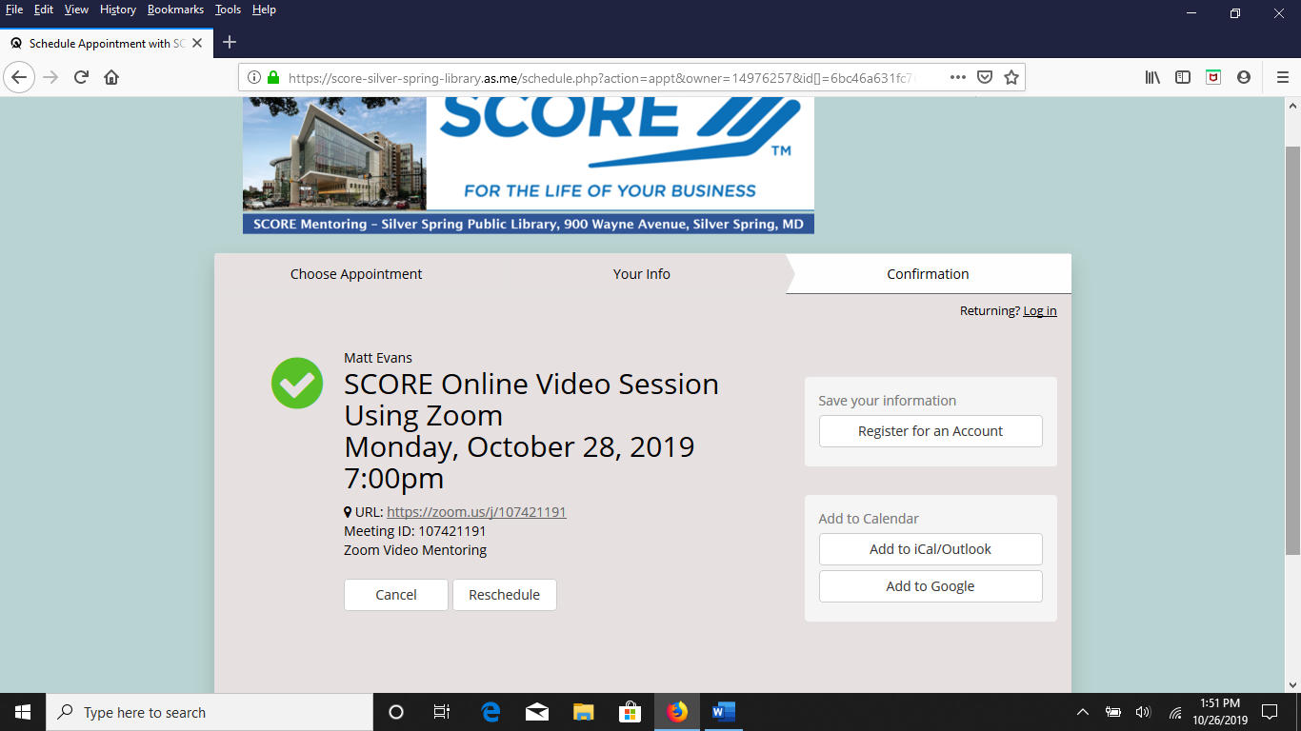
Check your email – you should get a confirmation email that your appointment has been booked:
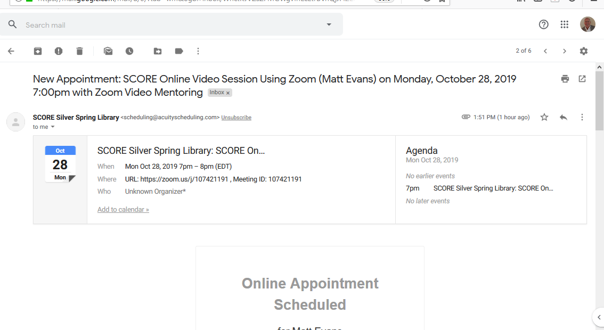

You will also get a reminder email 24 hours before your appointment:
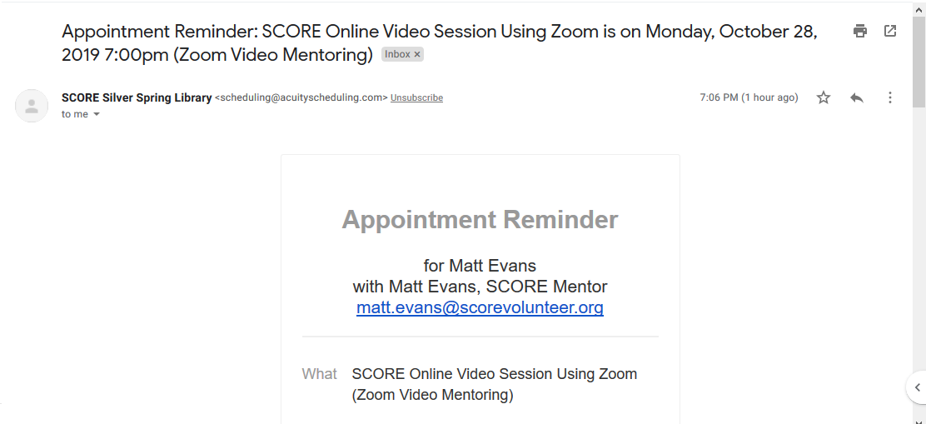

If you cannot make your appointment, please make sure to cancel by clicking on the button contained in the bottom part of the email:

NOTE: If you fail to cancel or re-schedule your appointment and you do not show up, then you will be blocked from making future appointments at the Silver Spring Library. We get over 400 requests per month and we cannot afford downtime given the demand for SCORE mentoring. So please respect the process and others when scheduling an appointment.

SCORE Mentor for Silver Spring Library:

Matt Evans
matt.evans@scorevolunteer.org

